3.3 Extension Problems

*You must show all work and get the problem correct to earn +1 extra homework credit for each problem*

1.

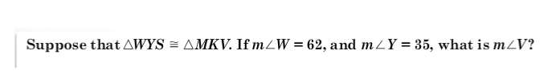

2.

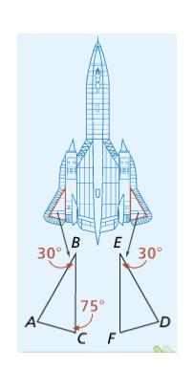The wings of an SR-71 Blackbird (pictured at the right) suggest congruent triangles. What is m<D?

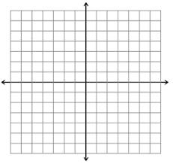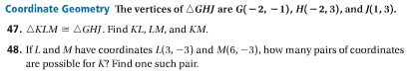Use the graph below for problems #47 and #48

**HINT:** when it says “Find KL, LM, and KM” it is talking about the *length* or *distance* of those three segments

